

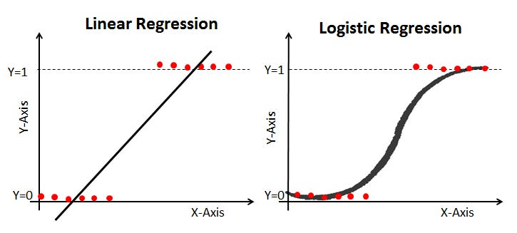

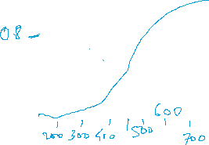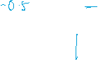

|  |  |  |
| --- | --- | --- |
|  | Predicted Positive | Predicted Negative |
| Actual Positive | True Positive (TP) | False Negative (FN) |
| Actual Negative | False Positive (FP) | True Negative (TN) |

Confusion Matrix for loan approval -100 rows

Scenario

Positive Class (1): Loan Approved

Negative Class (0): Loan Not Approved

Assuming:

* True Positives (TP): 50
* True Negatives (TN): 40
* False Positives (FP): 10
* False Negatives (FN): 20

|  |  |  |
| --- | --- | --- |
|  | Predicted Positive | Predicted Negative |
| Actual Positive | TP - 50 | FN – 20 |
| Actual Negative | FP - 10 | TN – 40 |

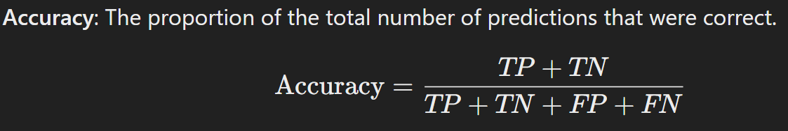

**Confusion Matrix for Disease Prediction**

Scenario

Positive Class (1): Disease Detected

Negative Class (0): No Disease

Confusion Matrix

Assuming:

True Positives (TP): 30

True Negatives (TN): 50

False Positives (FP): 15

False Negatives (FN): 5

|  |  |  |
| --- | --- | --- |
|  | Predicted Positive | Predicted Negative |
| Actual Positive | TP - | FN – |
| Actual Negative | FP - | TN – |

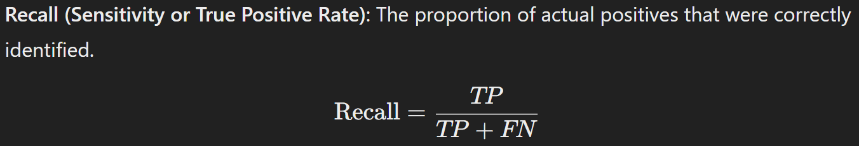

**Confusion matrix for spam/non-spam email classification**

Consider a dataset where we have 100 instances, and we use a classification model to predict whether an email is spam (positive) or not spam (negative)

Assume

TP = 40 (40 spam emails correctly classified as spam)

FN = 10 (10 spam emails incorrectly classified as not spam)

FP = 5 (5 not spam emails incorrectly classified as spam)

TN = 45 (45 not spam emails correctly classified as not spam)

|  |  |  |
| --- | --- | --- |
|  | Predicted Positive | Predicted Negative |
| Actual Positive | TP - | FN – |
| Actual Negative | FP - | TN – |

